**USING RAPTOR – AMSTRONG NUMBER OR NOT**

**ANIRUDH.R(192011013)**

**FLOWCHART**

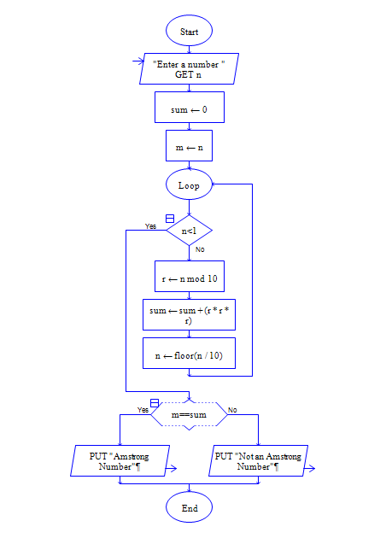

**INPUT**

371

**OUTPUT**

